Securing Linux Devices
Andree Salvo
Southern New Hampshire University
CYB 300-14668
Instructor: Jason Keltner

CYB 300 Module One Lab Worksheet

Complete this worksheet by replacing the bracketed phrases in the Response column with the relevant information. For all screenshots, include your name in the command line.

Lab: Securing Linux Devices

Exercise 1: Secure an Alma Device
Prompt | Response
Task 1: Take a screenshot of Step 3 showing the sudo sestatus command. Add your name in the command line. | 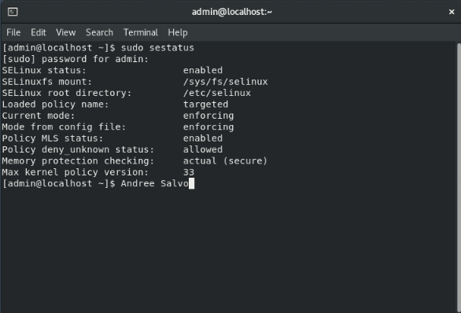
Task 1: Take a screenshot of Step 5 showing sudo setenforce permissive. Include your name in the command line. | 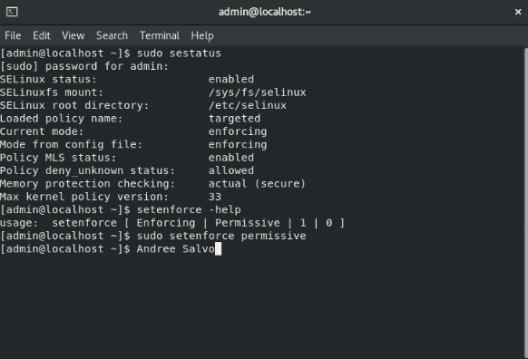
Task 3: Take a screenshot of Step 5 showing the context label of the website folder changed. Include your name in the command line. | 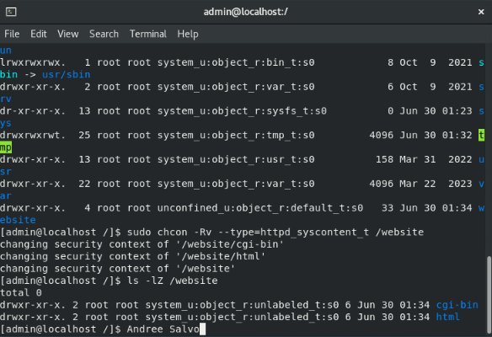
Why is it important to show the status and context label of the website folder? | Showing the status and context label is key because it reveals the folder’s security, name, user roles, and access levels—helping prevent mislabeling and supporting better access control.
Task 3: Take a screenshot of Step 9 showing Port 50080 being added to the SELinux. | 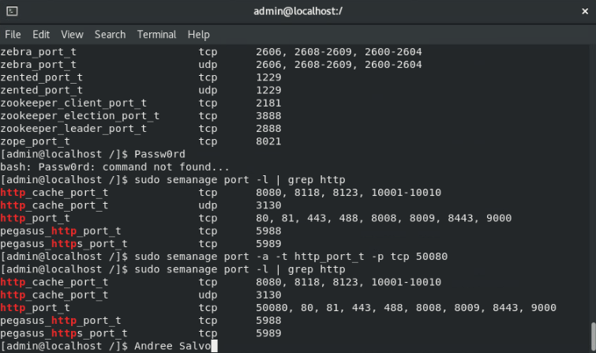
What is the significance of showing the port addition? | Showing the port addition matters because it clarifies how the server is being accessed, makes troubleshooting much easier, supports secure setups, and keeps things very organized.

Exercise 2: Secure an Ubuntu Device
Prompt | Response
Task 3: Take a screenshot of Step 7 showing the apparmor has been enabled to protect the apache server. | 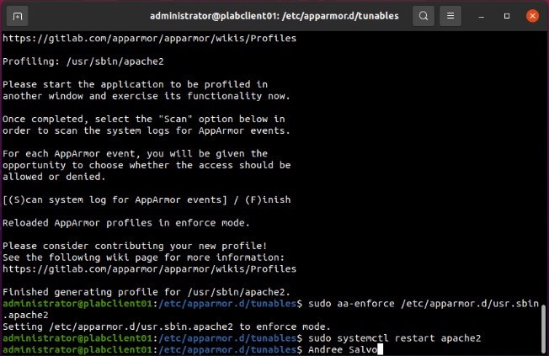
What is the importance of apparmor when it comes to protecting the apache server? | Apparmor protects the Apache server by restricting access to all but the most essential parts of the system. If an attacker finds a way to exploit a bug in Apache or one of its modules, Apparmor will limit the potential damage from that attack.

